List of data and comments

A) Raw data: bu1008#D11_T113102_NC.mdb – raw data converted from data nc-file
Concerning nc-files: from Sergei Denisov
1. You made a small mistake that causes crash of my converter. Don't be worry, but follow my instructions.
For example: Trigger_Delay = _, _, 50, _, 50, _, 50 - wrong declaration!
'_' means that value is not defined at all.
Should be Trigger_Delay = 0, 0, 50, 0, 50, 0, 50.
2. Background_Mode = 0, _, _, _, _, _, _ ;
Background_Low = 50000, 50000, 50000, 50000, 50000, 50000, 50000 ;
Background_High = 60000, 60000, 60000, 60000, 60000, 60000, 60000 ;
Mismatch in declaration.
Possible, should be = 1, 1, 1, 1, 1,1;

From
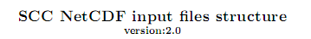

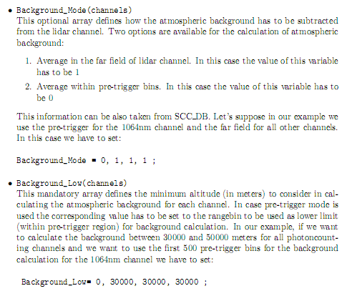

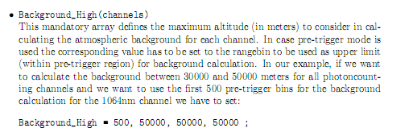

3. I made some temporary tricks to convert Your data to investigate this one for this moment, but please fix indicated problems for future use.
BRGDS, Sergei Denisov

- Synthesizer data:
- bu1008#D11_T113102_NC-2S.mdb – a part of bu1008#D11_T113102_NC.mdb file processed by Synthesizer program:
- bu1008#D11_T113102_NC.000 - bu1008#D11_T113102_NC.006 - averaged lidar signals after exclusion of signals with clouds layers;
Comments:
- It looks as if channels 89 (1064 nm) and 98 (355 nm, near zone) are exposed to influence of the electrical interference synchronized with laser sounding impulses (possible, discharge in flash lamp)

bu1008#D11_T113102_NC.007 - bu1008#D11_T113102_NC.010 - synthesized lidar signals from near and far zones measurements. List of signal used is in the column with Field name IDList
- Tropoexport data: Data file (mdb) processed by Tropoexport program and its Excel table copy.
- Bucharest Out : results of retrieving (mdb file, Excel copy and pictures).
- ProfileRetriever_v.23-03-2012: Retrieving program and Viewer

- Bucharest out
The results of retrieving lidar and radiometer data are presented: pictures, out.mdb-file, its Excel copy.

Two variants of input data are used:
- Backscatter signals at the wavelength 355 fnd 1064 nm and parallel polarized component of lidar signal at the wavelength 532 nm
- The same + cross-polarized component of lidar signal at the wavelength 532 nm

- ProfileRetriever_23-03-2012
Retrieving program with input and output files

