ProfileRetriever Software Package (RamanRetriever):

Implementation of Lidar-Radiometer Inversion Code (LIRIC)

with Graphical User Interface

Software User Manual
“ProfileRetriever(RamanRetriever)” software package consists of two graphical user interface applications, launched by means of opening “RamanRetriever.pyw” and “OutputViewer.pyw” files located at the root of the software package folder.
“RamanRetriever.pyw” is the main application. It is responsible for selection and graphical visualization of input data and the process of retrieval of aerosol extinction and backscatter coefficients profiles itself.
“OutputViewer.pyw” is an auxiliary application intended for browsing of retrieved aerosol profile databases created within the main application.
Graphical user interface of “RamanRetriever” application is represented on Fig. 1.
Application window is divided vertically into two primary parts. These user interface sections are responsible for selection of lidar input data, and aerosol profile output database, respectively.

Selecting lidar input data
Left part of the main application window (see Fig. 1) is responsible for selection of lidar input data. It is currently assumed that lidar data are stored in databases in Microsoft Access format and that these input databases already include any of the data fields required by the aerosol profile retrieval algorithm. To prepare lidar input databases, one has to use the “TropoExport” tool from “TropoSuite” package.
To select a database file, press the “‍” (“Open”) button located to the right of the text field denoted with “Lidar input” label (this text field will display the complete path to the opened database file). You may also reload the currently opened file by pressing the neighboring “” (“Reload”) button.
Contents of a loaded lidar database file are displayed in a table with the following columns (tooltips at table’s headers are also available for quick reference):
- “Date”, “TStart”, “TStop”: date and time boundaries for the lidar measurement (date and time of the moment when the measurement had started, and time of the moment when it had completed).
- “Wave”: wavelength of the measurement, in nanometers.
- “Polar”: type of the measured lidar signal: “0” for unpolarized signal, “1” for Raman signal, “2” for cross-polarized lidar signal, and “3” for parallel-polarized lidar signal.
- “HStep”: vertical (“height”) step of the lidar data discretization grid, in meters.
- “Left”, “Right”: indices of the first and the last nodes of the lidar signal grid section selected to be used in aerosol profile retrievals (index 0 corresponds to lidar signal received from the range of 0 to “HStep” meters above the measurement point and so on).
- “Local ID”: textual identifier that was assigned to the lidar measurement during the lidar experiment.
Only those measurements that have been prepared for aerosol profile retrieval in “TropoExport” application (as determined by “TropoExport” database field set to “1”) are displayed in the table.

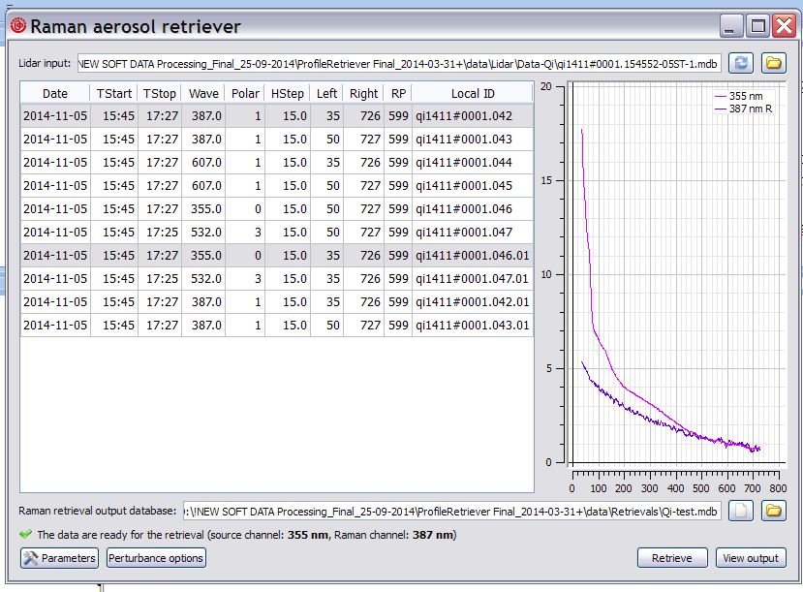
Fig. 1. Graphical user interface of “RamanRetriever” application.

When the database has loaded, you have to select a couple of lidar measurements for aerosol extinction and backscatter profile retrieval. To select a measurement, click the corresponding table row with mouse or move table cursor to one of the row’s cells and press the spacebar key.
The requirements to the selected couple:
- the wavelength of the lidar signals (355 and 387) or (532 and 607);
- parameter “Polar” should be equal 0 for 355 nm channel; 0 or 3 for 532 channel, and 1 for 387 and 607 channels;
- “Left” / “Right” lidar signal boundaries of the same couple should be coincide.
Lidar signals selected for retrieval are displayed in the plot located to the right of the table. Signals at 355 nm are displayed in purple color; signals at 532 nm are displayed in light-green; signals at 387 nm in lilac, and 607 nm in khaki.
Unit of the horizontal axis of the lidar plots is index of the lidar data grid. Thus, values along the horizontal axis of the plots are proportional to height above the measurement point (with multiplication factor being equal to the value displayed in “HStep” column of the lidar table). Vertical axis represents values of the lidar signals, divided by their average values around reference points. Indices of these reference points have to be defined within the “TropoExport” application during the lidar signal preparation procedure. Note that “TropoExport” will also perform averaging of lidar signals, so that most of the noise that is inherent to lidar data at high altitudes should normally have been removed by now.
It is possible to adjust sizes of window sections occupied by the lidar table and the plot by dragging their vertical boundary with mouse.

Selecting aerosol profile output database file
Lower part of the main application window (see Fig. 1) is intended for selection of the database file to append results of aerosol profile retrievals to. Currently, Microsoft Access is the only available format for output database files. You may either select an existing output database with the “‍‍” (“Open”) button located to the right of the text field denoted with “Aerosol profile output database” label (this text field will display the complete path to the selected output database file), or alternatively create a new database using the neighboring “‍‍” (“New”) button.

Running the aerosol profile retrieval algorithm
Aerosol profile retrieval algorithm is invoked by “Retrieve” button located in the lower right corner of the main application window (see Fig. 1). If the retrieval is not possible for some reason (e.g. lidar input database is not loaded or photometer measurement is not selected), “Retrieve” button will be disabled and an appropriate error message will be displayed in the status bar at the bottom of the application window.
Appearance of the dialog box that reflects the retrieval progress is given on Fig. 2. In case of a successful retrieval, plots that visually characterize the results are displayed in the dialog upon completion of the algorithm (Fig. 3).
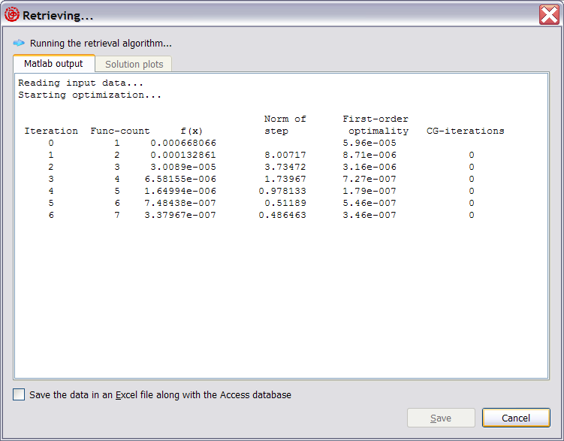
Fig. 2. Progress of an aerosol profile retrieval.
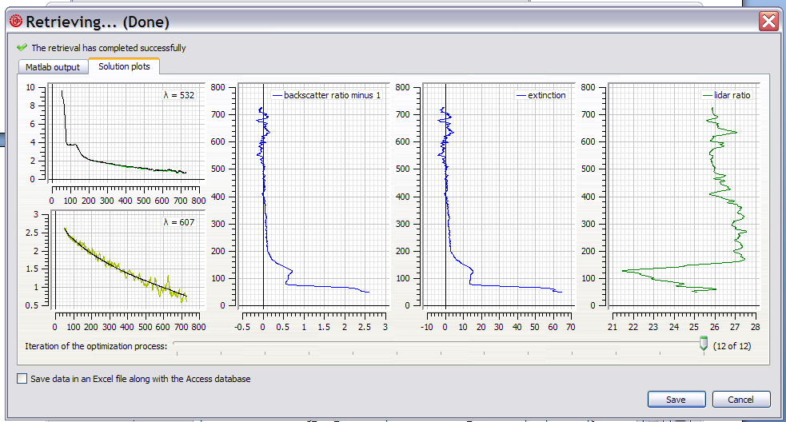
Fig. 3. Results of an aerosol profile retrieval.
Two plots, located to the left, represent lidar backscatter signals, normalized to their respective values at the reference points, with removed molecular extinction components. Color plots denote actually measured lidar signals (corrected according to the retrieved lidar ratios), whereas black ones denote modeled signals calculated in accordance with the retrieved aerosol parameter profiles. Additional numbers, displayed in the top right corner of the lidar plots, represent channel’s wavelength in nanometers (“λ”).
Two aerosol profiles are retrieved, namely “backscatter ratio minus 1”, “extinction” and “lidar ratio”.
Below the plots in the dialog depicted on Fig. 3 there is a slider control that makes it possible to look at intermediate steps of the optimization process. The rightmost position of the slider handle corresponds to the final retrieval results that will be saved in the database file, whereas the leftmost position of the handle corresponds to the initial approximation used in the optimization process. This visualization of the intermediate retrieval data is available in the retrieval dialog only.
To append the retrieved aerosol profiles to the database file (whose selection was described in Section 3), one has to press the “Save” button (see Fig. 3). It’s also possible to save the retrieval results in a file in Microsoft Excel format along with the database, by means of setting the corresponding checkbox in the lower part of the dialog window before the “Save” button is pressed. Directory and file name of the Excel file will coincide with that of the database, but its extension will be “.xls” instead of “.mdb”. If the file does not exist, then a new file, holding a single data record, is created. Otherwise, the data record is appended to the existing Excel file.
Main advantage of the Excel file format is that it provides more readable representation for data arrays. Contents of the data arrays will be stored in a separate worksheet, named “Arrays” (or in several worksheets whose names will start with “Arrays”, if there are too many data records to be accommodated in a single worksheet). Each data array will be stored in a single column. Number of the data record containing the array, and array’s name will be stored in the first and the second rows of the array’s column, respectively.

Adjusting algorithm’s parameters
The function that is minimized by the algorithm includes lidar signal residuals (2 signals), and also residuals for average lidar ratio, as well as 2 terms responsible for smoothness of the aerosol profiles being retrieved. Simultaneous optimization of these multiple heterogeneous parameters is accomplished by introduction of weighting coefficients whose values are to be chosen by the user on the basis of the algorithm’s convergence analysis.
You may adjust parameters of the retrieval process by means of the dialog box “Raman retrieval parameters” invoked via “Parameters” button located in the lower left corner of the main application window (see Fig. 1). Fields responsible for the weighting coefficients mentioned above are located in the left-hand part of the dialog box (see Fig. 4).

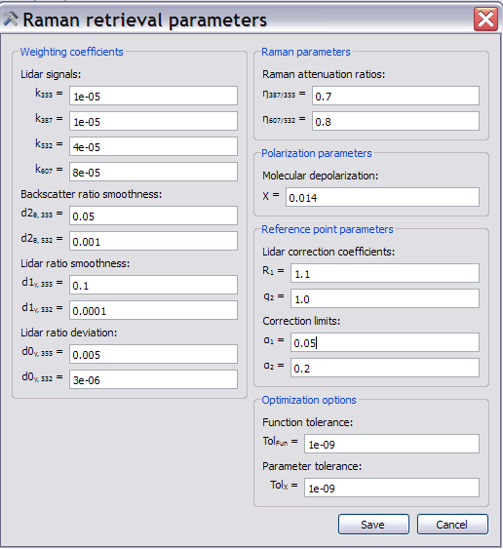
Fig. 4. Algorithm parameters dialog box
In the right-hand part of the dialog box it’s possible to adjust some additional parameters of the algorithm:
- “Raman attenuation ratio”: ratio of aerosol extinction at the wavelengths 387/355 and 607/532 nm.
- “Molecular depolarization”: depolarization ratio for the molecular atmosphere model (this value is assumed to be the same at any of the lidar wavelengths).
- Reference point parameters:
- Lidar correction coefficients: R1 – backscatter ratio for sounding wavelength; q2 – weight coefficient;
- Correction limits: possible deviation of R1 and q2.
- Optimization options:
- “Function tolerance” (Tol_{Fun}): maximum value for decrease of the function being minimized between successive iterations that should trigger termination of the optimization process.
- “Parameter tolerance” (Tol_{X}): maximum value for change made to the parameters being optimized between successive iterations that should trigger termination of the optimization process.
Pressing the “Save” button will apply new parameter values for all the subsequent runs of the retrieval algorithm. Pressing “Reset to defaults” button will reset all the values displayed in the dialog to their default values as defined within the application’s program code. Pressing “Cancel” button will close the dialog box without saving any changes.

Estimation of square deviation of the retrieved aerosol parameters
The square deviation of the retrieved aerosol backscatter and extinction coefficients can be estimated by a special procedure providing by the LIRIC. The Errors modeling module of the LIRIC package generates a disturbed input data set by adding the random noise into original lidar signals and by disturbing their linear characteristics. Real measurement conditions and technical features of the lidar system should be taken into account in setting parameters of the module.
You may adjust parameters of the errors modeling by means of the dialog box “Raman Perturbance options” invoked via “Perturbance options” button located in the lower left corner of the main application window (see Fig. 1). The dialog box “Raman perturbance options” is shown in Fig. 5.

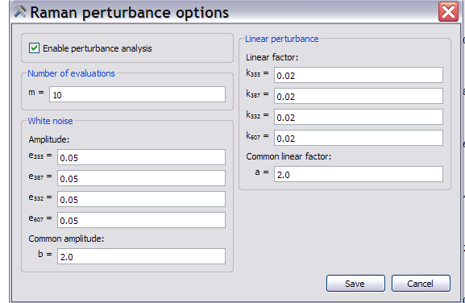
Fig. 5. Raman pertuabence options parameters dialog box
The left-hand part of the dialog box contains parameters responsible for:
- “Enable perturbance analysis” - switching-on of the perturbance analysis;
- “Number of evaluations” – number of realizations modeled;
- “Amplitude” – maximum amplitudes of the noise in lidar channeles;
- “Common amplitude” – common coefficient of the error amplitudes.
- The right-hand part of the dialog box contains parameters responsible for:
- “Linear factors” – coefficient of linear distortions of lidar channels;
- “Common linear factor” - common coefficient of the linear factors.

Browsing of retrieved aerosol profile databases
For browsing of retrieved aerosol profile databases, a separate “OutputViewer” application is provided, that may be launched either on its own or via the “View output” button located in the lower right corner of the main application window (see Fig. 1).
Graphical user interface of the “OutputViewer” application is represented on Fig. 6. To select a database file to be displayed in the application window, one has to press the “‍‍” (“Open”) button located in the top right corner of the window. It’s also possible to reload the currently opened database file by pressing the neighboring “‍‍” (“Reload”) button.
Contents of the loaded database are represented in the form of a table with the following columns (tooltips at table’s headers are also available for quick reference):
- “Date”, “TStart”: date and time of the beginning of the earliest of the lidar measurements used in the retrieval.
- “TStop”: completion time of the latest of the lidar measurements used in the retrieval.
- “DRetr”, “TRetr”: completion date and time of the aerosol profile retrieval algorithm run.
- “HStep”: height step of the lidar data discretization grid, in meters (a common value for all the lidar signals).
- “Source”: wavelength of the sounding signal, nm.
- “Raman”: wavelength of the raman signal, nm.
- “R-source”, “R-Raman ”: residuals for the lidar signal components of the function that was minimized by the retrieval algorithm.
- “Rsm-Bs”, “Rsm-L”, “Rsm-dev”: residuals for smoothness terms of the function that was minimized.
Lower part of the “OutputViewer” application window is occupied by plots that visually characterize results of the currently selected retrieval. These plots represent the same data that are displayed upon successful completions of aerosol profile retrievals, as described in Section 4 (see Fig. 6). Dashed lines present aerosol parameters + square deviation.
“Save plots as” button, located in the lower left corner of the application window, makes it possible to save the currently displayed plots in an image file, either in PNG (Portable network graphics) or EMF (Windows enhanced metafile) format.
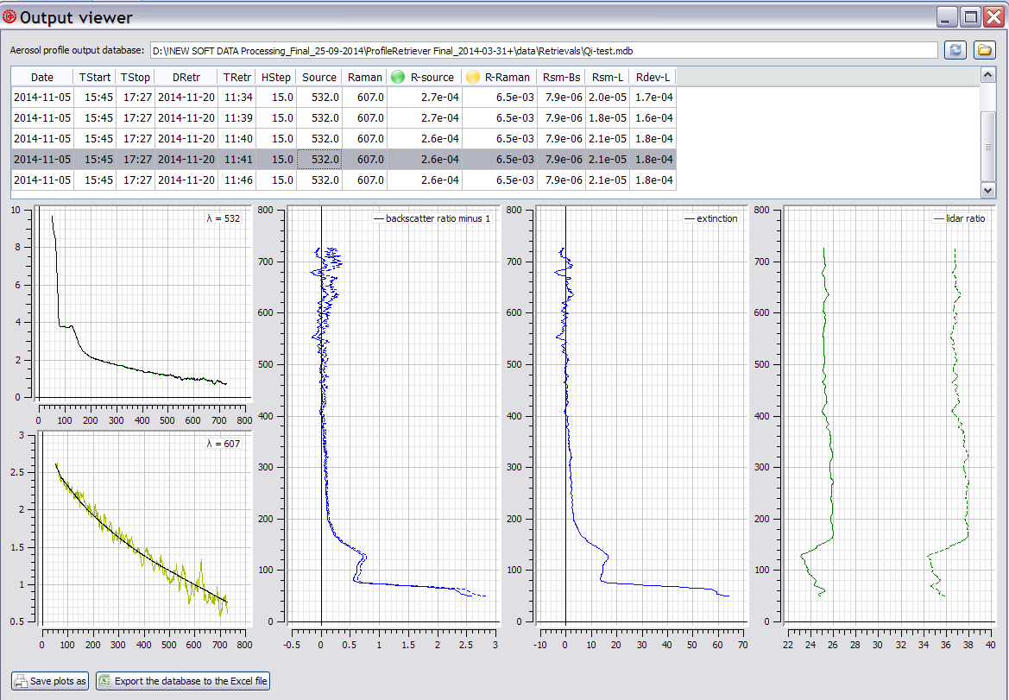
Fig. 6. Graphical user interface of “OutputViewer” application; dashed lines present aerosol parameters + square deviation.
“Export the database file to an Excel file” button makes it possible to export the entire database being displayed to a file in Microsoft Excel format, whose name and structure will be the same as those used in Excel file saving procedure described in Section 4.
It is possible to adjust sizes of window sections occupied by the table and the plots by dragging their horizontal boundary with mouse.

Appendix. List of data fields of the aerosol profile output databases
The most important data fields of the aerosol profile output databases created by “ProfileRetriever” package may be accessed by means of the “OutputViewer” application, as described in Section 6. However, the actual number of stored parameters is considerably larger than that accessible via the user interface. In this appendix, the complete list of the output database data fields is provided, along with their data types:
“AerosolProfiles” page of the Excel table:
- “Latitude”, “Longitude”, “Altitude” (float32): geodetic coordinates, in decimal degrees, and altitude above sea level, in meters, of the lidar measurement site (taken from the input lidar database). These values have to be the same for all the input lidar signals.
- “StartDate”, “StopDate”, “StartTime”, “StopTime” (date/time): date and time boundaries for the set of lidar measurements used in the retrieval (starting time of the earliest of the lidar measurements, and completion time of the latest one).
- “RetrievalDate”, “RetrievalTime” (date/time): completion date and time of the aerosol profile retrieval algorithm run.
- “Step” (float32): height step of the lidar data discretization grid, in meters. This value has to be the same for all the lidar signals.
- “Zenith” (float32): zenith angle of the lidar data discretization grid, in degrees (this value is always zero).
- “LeftSource”, “LeftRaman” (float32): the left boundary of sounding and Raman signals.
- “Wavelength_Source”, “Wavelength_Raman” (float32): the wavelength of sounding and Raman signal, respectively.
- “Polarization_Source”, (int16): types of the measured ordinary input lidar signals: these values may be either “0” (for unpolarized input signals) or “3” (for parallel-polarized ones).
- “IDLocal_Source”, “IDLocal_Raman” : (text fields, up to 255 characters): textual identifiers that were assigned to input lidar measurements during the lidar experiments.
- “AtmoModel” (text field, up to 255 characters): textual identifier for the molecular atmosphere model that was specified in the “TropoExport” tool during preparation of the lidar data: either “STD” for International Standard Atmosphere 1976, “CIRA” for COSPAR International Reference Atmosphere 1986 or “CUST” for a custom molecular atmosphere model.
- “Weight_Source”, “Weight_Raman”, (float32): weighting coefficients for the lidar equations (see Section 4).
- “WeightSmooth_Backscatter”, “WeightSmooth_Lidar”, (float32): weighting coefficients for estimation of the smoothness of backscatter coefficients and lidar ratio profiles.
- “MolDepolar” (float32): molecular depolarization ratio at sounding wavelength.
- “AttenuationRatio” (float32): the ratio of aerosol extinctions at the sounding and Raman wavelength.
- “RE OMT_Source”, “RE OMT_Raman” - estimates for relative errors of molecular optical thicknesses at input lidar channels (as specified in the “TropoExport” tool)
- “RE OAT_Source”, “RE OAT_Raman”, “(float32): estimates for relative errors of aerosol optical thicknesses at input lidar channels (as specified in the “TropoExport” tool).
- “RE GBS_Source”, “RE GBS_Raman” (float32): relative errors of lidar ratio estimation (as specified in the “TropoExport” tool).
- “Ratio_Source”, “Ratio_Raman” (float32): lidar ratios for the various lidar channels in the referent point.
- “Residual_Source”, “Residual_Raman”, (float32): residuals for the lidar signal components of the function that was minimized by the retrieval algorithm.
- “ResSmooth_Backscatter”, “ResSmooth_Lidar”, “ResDeviat_Lidar”, (float32): residuals for smoothness terms of the function that was minimized.
- “ResDeviat_Lidar”, (float32): residuals for deviation term of the function that was minimized.
- “RatioDispersion_Source”, “RatioDispertion_Raman” (float32): deviations of lidar ratios for the various lidar channels in the referent point.
- “PerturbanceEvaluations”, “WhiteNoise_Source”, “WhiteNoise_Raman”, “LinearNoise_Source”, “LinearNoise_Raman” (float32): parameters of Pertuabence options parameters dialog box

“Arrays” page of the Excel table:
- “BackscatterMin1Profile”: profile of “backscatter ratio-1”
- “LidarRatioProfile”: lidar ratio profile.
- “Measured_Source”, “Measured_Raman”: measured sounding and Raman signals.
- “Calculated_Source”, “Calculated_Raman”: calculated sounding and Raman signals.
- “StdDeviation_Source”, “StdDeviation_Raman”: deviations of sounding and Raman lidar signals (as specified in the “TropoExport” tool).
- “MolBackscatter”: Molecular backscatter coefficient profile (model) (as specified in the “TropoExport” tool).
- “AerBackscatter”: Aerosol backscatter coefficient profile (retrieved) .
- “AerExtinction”: Aerosol extinction coefficient profile (retrieved) .
- “BackscatterMin1Dispersion”: square deviation of the backscatter ratio-1” profile.
- “LidarRatioDispersion”: square deviation of the lidar ratio profile.

