# ProfileRetriever Software Package:

# Implementation of Lidar-Radiometer Inversion Code (LIRIC)

# with Graphical User Interface

## Software User Manual

“ProfileRetriever” software package consists of two graphical user interface applications, launched by means of opening **“ManualRetriever.pyw”** and **“OutputViewer.pyw”** files located at the root of the software package folder.

**“ManualRetriever.pyw”** is the main application. It is responsible for selection and graphical visualization of input data and the process of retrieval of aerosol mode concentration profiles itself.

**“OutputViewer.pyw”** is an auxiliary application intended for browsing of retrieved aerosol profile databases created within the main application.

Graphical user interface of “ManualRetriever” application is represented on Fig. 1. Application window is divided vertically into three primary parts, marked off with red rectangles on the figure. These user interface sections are responsible for selection of lidar input data, photometer input data, and aerosol profile output database, respectively.

### Selecting lidar input data

Upper part of the main application window (see Fig. 1) is responsible for selection of lidar input data. It is currently assumed that lidar data are stored in databases in Microsoft Access format and that these input databases already include any of the data fields required by the aerosol profile retrieval algorithm. To prepare lidar input databases, one has to use the “TropoExport” tool from “TropoSuite” package.

To select a database file, press the “‍‍” (“Open”) button located to the right of the text field denoted with **“Lidar input”** label (this text field will display the complete path to the opened database file). You may also reload the currently opened file by pressing the neighboring “‍‍” (“Reload”) button.

Contents of a loaded lidar database file are displayed in a table with the following columns (tooltips at table’s headers are also available for quick reference):

* **“Date”, “TStart”, “TStop”:** date and time boundaries for the lidar measurement (date and time of the moment when the measurement had started, and time of the moment when it had completed).
* **“Wave”:** wavelength of the measurement, in nanometers.
* **“Polar”:** type of the measured lidar signal: “0” for unpolarized signal, “1” for Raman signal, “2” for cross-polarized lidar signal, and “3” for parallel-polarized lidar signal.
* **“HStep”:** vertical (“height”) step of the lidar data discretization grid, in meters.
* **“Left”, “Right”:** indices of the first and the last nodes of the lidar signal grid section selected to be used in aerosol profile retrievals (index 0 corresponds to lidar signal received from the range of 0 to “HStep” meters above the measurement point and so on).
* **“Local ID”:** textual identifier that was assigned to the lidar measurement during the lidar experiment.

Only those measurements that have been prepared for aerosol profile retrieval in “TropoExport” application (as determined by “TropoExport” database field set to “1”) are displayed in the table.

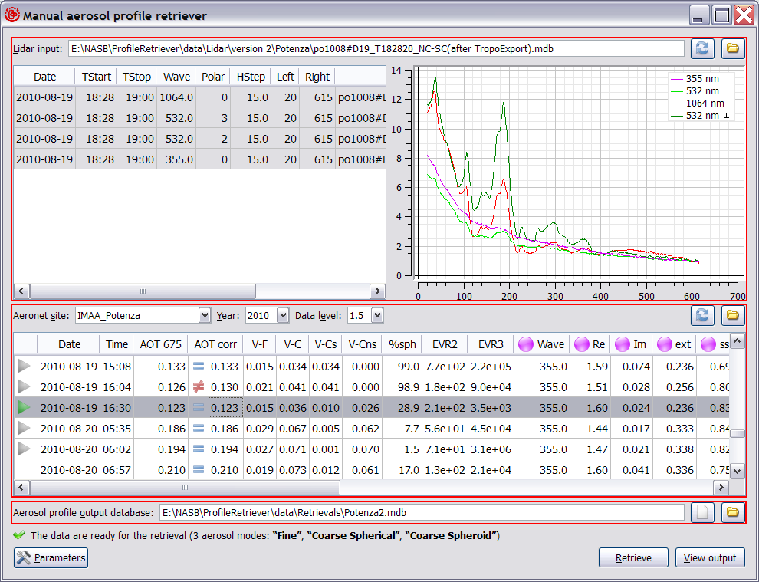

*Fig. 1. Graphical user interface of “ManualRetriever” application.*

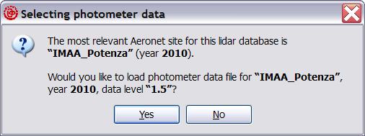

*Fig. 2. Dialog box suggesting photometer data for a newly opened lidar database.*

Whenever you load or reload a lidar database, its content is analyzed, and an appropriate photometer measurement site and year are suggested (see Fig. 2). Normally, all the measurements contained within a lidar database should have been carried out at the same site (so that geodetic coordinates stored in the database file are the same for any of the data records). In that case, AERONET site suggested will be the nearest one with respect to the geodetic coordinates stored in the lidar database. Otherwise, the most frequent combination of latitude, longitude and measurement year will be used instead.

When the database has loaded, you have to select lidar measurements for aerosol profile retrieval. To select a measurement, click the corresponding table row with mouse or move table cursor to one of the row’s cells and press the spacebar key.

Currently, it is possible to retrieve aerosol profiles in either simplified or polarimetric retrieval mode. In either case, it is required that exactly one unpolarized (or, alternatively, parallel-polarized) lidar signal is selected for each of the following wavelengths: 355, 532, and 1064 nm. If only these three unpolarized measurements are selected, then the retrieval will proceed in the simplified mode, making it possible to retrieve 2 aerosol modes: “Fine” and “Coarse”. Parameters of the aerosol modes will be determined from the corresponding AERONET measurement.

Polarimetric mode of the algorithm is turned on by selecting an extra cross-polarized lidar measurement for 532 nm, if it is available. In polarimetric mode, it will be possible to retrieve 3 aerosol modes: “Fine” aerosol mode similar to that mentioned above, and also “Coarse Spherical” and “Coarse Spheroid” aerosol modes that will replace the “Coarse” mode of a simplified retrieval.

Lidar signals selected for a retrieval are displayed in the plot located to the right of the table. Signals at 355 nm are displayed in purple color; unpolarized signals at 532 nm are displayed in light-green; signals at 1064 nm in red, and cross-polarized signals at 532 nm in dark-green.

Unit of the horizontal axis of the lidar plots is index of the lidar data grid. Thus, values along the horizontal axis of the plots are proportional to height above the measurement point (with multiplication factor being equal to the value displayed in “HStep” column of the lidar table). Vertical axis represents values of the lidar signals, divided by their average values around reference points. Indices of these reference points have to be defined within the “TropoExport” application during the lidar signal preparation procedure. Note that “TropoExport” will also perform averaging of lidar signals, so that most of the noise that is inherent to lidar data at high altitudes should normally have been removed by now.

It is possible to adjust sizes of window sections occupied by the lidar table and the plot by dragging their vertical boundary with mouse.

### Selecting radiometric input data

Middle part of the main application window (see Fig. 1) is responsible for selection of a radiometric measurement corresponding to lidar data selected in the upper part of the window (see Section 1).

Radiometric data are assumed to be stored in plain text files on the local computer and have to be placed at some predefined locations with respect to the so-called “root folder of the photometer database”. By default, that folder is assumed to be **“data\AERONET”** subfolder of the application’s root. If required, you may change location of the photometer database root folder via “‍‍” (“Open”) button located at the right-hand side of the application window, just above the table that displays photometer data. Such an operation may be useful, for example, if one has several versions of “ProfileRetriever” package and wants all these versions of the software to share a single photometer database.

Predefined directory structure of a photometer database is as follows. Names of subfolders of first level (i.e. subfolders of the photometer database’s root) should exactly coincide with names of the required AERONET sites. Names of subfolders of second level should represent measurement years (e. g. “2012”), whereas names of subfolders of third level should represent product data levels (either “Level 1.5” or “Level 2.0”). Data files are to be stored at the bottom of the folder hierarchy. Currently, there are three types of these photometer data files: original AERONET inversion products (files with “dubovik” extension), photometer input files processed with AERLID tool (“lidar.txt” extension), and auxiliary data files holding corrected aerosol optical thicknesses (“aot.txt” extension).

Whenever you want to add photometer data to the local database or update existing photometer data, you have to manually download the respective AERONET Version 2 inversion product from the official AERONET web site (<http://aeronet.gsfc.nasa.gov/cgi-bin/webtool_opera_v2_inv>). In order for a downloaded product file to be usable by the “ProfileRetriever” package, it is required that it spans an entire measurement year. In other words, you have to specify “January, 1” and “December, 31” (of the same year) as “start and end time of the data download period” in the download product web page. Then you have to choose **“Combined File (all products without phase functions)”** option in the “Derived Inverison Products” box, and “All Points” in “Data Format”. When you press the “Download” button and agree to the AERONET data usage conditions, you should receive a ZIP archive containing a single file whose name should be “*yy*0101_*yy*1231_*SiteName*.dubovik”, where *yy* is a two-digit year code and *SiteName* is the AERONET site name. This inversion product file has to be manually placed at the appropriate location within the photometer database’s folder hierarchy (namely, at its “*SiteName*/​*year*/​Level *x.x*/” subfolder). If the required folders don’t exist, they have to be manually created as well.

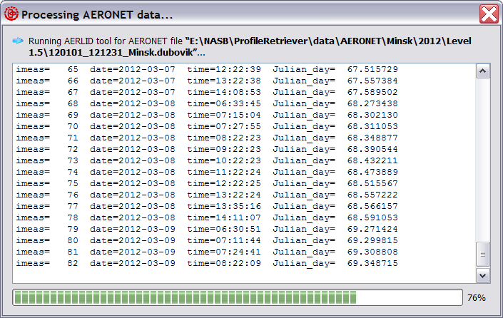

*Fig. 3. Dialog box displaying the progress of an AERONET product preliminary processing.*

In the application window, selection of the required photometer data subset (i.e., the required photometer data file) is accomplished by means of combo boxes denoted with **“Aeronet site”, “Year”,** and **“Data level”** labels respectively (see Fig. 1). However, under normal circumstances it should not be necessary to select AERONET site and measurement’s year by hand, as appropriate values for these parameters are suggested automatically whenever a lidar database file is opened or reloaded. These two parameters may be brought into line with the currently selected lidar database at any time by pressing the “‍‍” (“Reload”) button located to the right of the text field holding the lidar database file path, and then pressing “Yes” (see Section 1 and Fig. 2). On the other hand, data level of AERONET measurements has to be always selected manually.

When a new AERONET inversion product is added to the photometer database, or an existing product is updated, it will be automatically processed with AERLID tool as soon as the corresponding photometer data subset is selected by the user (see Fig. 3). During this preliminary processing step, photometer data will be recalculated at lidar wavelengths, and an additional data file with “lidar.txt” extension will be created (or overwritten) to hold the recalculated data. Normally, “ProfileRetriever” will only perform preliminary processing once for a given product file, using creation time stamps of the corresponding “dubovik” and “lidar.txt” files to determine its necessity. If preliminary processing step fails to be launched for some reason, you may enforce it by manually deleting the data file with “lidar.txt” extension.

Once an appropriate photometer data subset is selected, either automatically or via the combo boxes, photometer data file will be loaded, and its contents displayed in the photometer data table (located below the combo boxes), which has the following columns (tooltips at table’s headers are also available for quick reference):

* **“Date”, “Time”:** date and time of the photometer measurement.
* **“AOT 675”:** aerosol optical thickness at 675 nm wavelength, as measured by the Sun photometer.
* **“AOT corr”:** manually corrected value for the “AOT 675” column (this value may be edited by the user; its modification may be useful, for example, in cases when no full-scale radiometric measurement exists that perfectly matches date and time of the lidar experiment).
* **“V-F”, “V-C”, “V-Cs”, “V-Cns”:** volumetric concentrations of various aerosol modes, namely “Fine”, “Coarse”, “Coarse Spherical”, and “Coarse Spheroid” (i.e., “Coarse Non-spherical”), in micrometers (representing aerosol volume, in μm3, for an atmosphere column with 1 μm2 cross section), that have been obtained by means of AERONET radiometric inversion algorithm and corrected according to the manually entered values in the “AOT corr” column, if required.
* **“%sph”:** fraction of spherical aerosol particles, as retrieved by the AERONET inversion algorithm, in percents (this fraction will be equal to ratio between “V-Cs” and “V-C”, the latter being defined, in its turn, to be the sum of “V-Cs” and “V-Cns”).
* **“EVR2”, “EVR3”:** eigenvalue ratios for 2-mode and 3-mode aerosol backscatter matrices, respectively. These values are obtained in the following way: first, a 2×3 or 3×4 matrix of aerosol backscatter coefficients (as retrieved by the AERONET inversion algorithm) is formed, with its rows representing aerosol modes to be retrieved and columns representing input lidar channels (for the 2-mode matrix, the modes are “Fine” and “Coarse”, and lidar channels are the unpolarized ones for 355, 532, and 1064 nm; for the 3-mode matrix, the modes are “Fine”, “Coarse Spherical”, and “Coarse Spheroid”, and lidar channels are supplemented with the cross-polarized one at 532 nm); then that matrix is multiplied by itself transposed and the ratio between the greatest and the smallest eigenvalues of the resulting positively defined matrix is calculated. These values may be used to assess robustness of the retrieval algorithm for simplified and polarimetric retrieval modes, respectively.
* **“Wave”:** wavelength, in nanometers, that the following aerosol parameters are specified for (these columns contain the predefined lidar wavelengths and are provided merely for clarity).
* **“Re”:** real part of aerosol complex refractive index at the given wavelength.
* **“Im”:** imaginary part of aerosol complex refractive index at the given wavelength.
* **“ext”:** aerosol extinction optical thickness at the given wavelength, corrected according to the manually entered values for “AOT corr”, if required.
* **“ssa”:** aerosol single scattering albedo at the given wavelength.
* **“F11”:** main (first diagonal) element of the aerosol scattering matrix at the given wavelength.
* **“F2/1”:** second diagonal element of the aerosol scattering matrix, divided by its main (first diagonal) component, at the given wavelength.

Values in the “AOT corr” column may be edited by double-clicking a cell with mouse or by pressing “F2” key on the keyboard (see Fig. 4). A cell’s icon will look like a blue equals sign if values in “AOT 675” and “AOT corr” columns are the same, and like a red not equal sign otherwise. Changes made by the user to values in this column, if any, will be saved in an additional data file with “aot.txt” extension (mentioned above) when the application window is closed. If you want to remove manual AOT correction for a given photometer measurement, you have to enter a value for “AOT corr” that coincides with that in the “AOT 675” column (note that strict coincidence is not required: “AOT corr” value will actually stick to “AOT 675” whenever it happens to look the same due to rounding used within the photometer table).

If you want to save changes made in the “AOT corr” column immediately, you may use the “‍‍” (“Reload”) button located above the photometer table at the right-hand side of the application window. This same button may also be used to reload the currently selected photometer data file, and also to launch the preliminary processing with AERLID tool for the currently selected photometer data subset (if a newer version of the AERONET inversion product was downloaded recently for it).

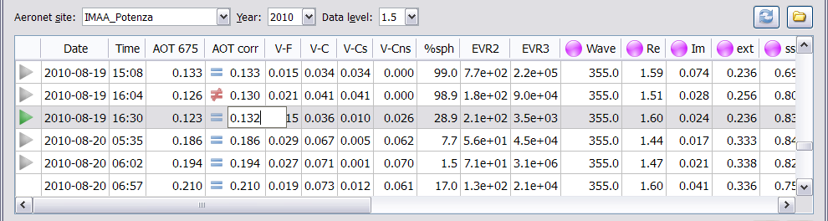

*Fig. 4. A cell of the “AOT corr” column being edited.*

In order to retrieve aerosol profiles, you have to select an appropriate photometer measurement from the table, by either clicking a table row with mouse or by moving table cursor to one of the row’s cells and pressing the spacebar key. Normally, you should select a measurement that is as close to the lidar ones as possible. In order to facilitate selection of such a measurement, lidar synchronization markers (green or grey triangles) are displayed in the leftmost column of the photometer data table.

Synchronization markers denote photometer measurements that are separated by at most 12 hours from every one of the selected lidar measurements. Among these, the green-colored triangle is used to denote the nearest photometer measurement with respect to median time of the lidar experiment (i.e., the middle value between start time of the earliest of the selected lidar measurements and finish time of the latest one). Whenever you update selection of the lidar signals (see Section 1), lidar synchronization markers are updated as well, and the photometer table itself is scrolled, so that the nearest photometer measurement (with respect to the selected lidar ones) appears at its center. Note that this table scrolling will occur even in the case when neither of the photometer measurements is denoted with a marker (for example, if year of the photometer data is different from that of the lidar measurement). On the other hand, geographical location of the photometer site is not taken into account and does not have any effect on the synchronization markers.

It is possible to adjust sizes of the upper and the middle parts of the window (i.e. those responsible for lidar and radiometric input data, respectively) by dragging their horizontal boundary with mouse (see Fig. 1).

### Selecting aerosol profile output database file

Lower part of the main application window (see Fig. 1) is intended for selection of the database file to append results of aerosol profile retrievals to. Currently, Microsoft Access is the only available format for output database files. You may either select an existing output database with the “‍‍” (“Open”) button located to the right of the text field denoted with **“Aerosol profile output database”** label (this text field will display the complete path to the selected output database file), or alternatively create a new database using the neighboring “‍‍” (“New”) button.

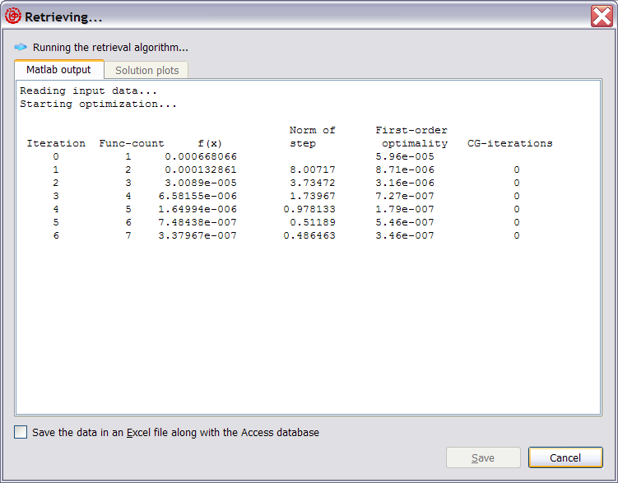

*Fig. 5. Progress of an aerosol profile retrieval.*

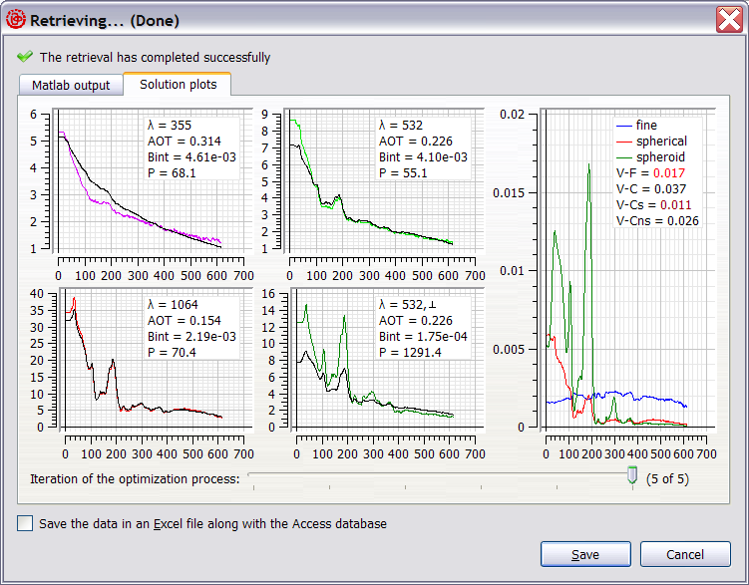

*Fig. 6. Results of an aerosol profile retrieval.*

### Running the aerosol profile retrieval algorithm

Aerosol profile retrieval algorithm is invoked by “Retrieve” button located in the lower right corner of the main application window (see Fig. 1). If the retrieval is not possible for some reason (e.g. lidar input database is not loaded or photometer measurement is not selected), “Retrieve” button will be disabled and an appropriate error message will be displayed in the status bar at the bottom of the application window.

Appearance of the dialog box that reflects the retrieval progress is given on Fig. 5. In case of a successful retrieval, plots that visually characterize the results are displayed in the dialog upon completion of the algorithm (Fig. 6).

Horizontal axes of the plots represent indices of the lidar data grid (similar to lidar plots described in Section 1). Vertical axis of the rightmost plot represents concentrations of the retrieved aerosol modes, in parts per billion (ppb). Vertical axes of the remaining plots, located to the left, represent lidar backscatter signals, normalized to their respective values at the reference points, with removed molecular extinction components. Color plots denote actually measured lidar signals (corrected according to the retrieved lidar ratios), whereas black ones denote modeled signals calculated in accordance with the retrieved aerosol concentration profiles. Additional numbers, displayed in the top right corner of the lidar plots, represent channel’s wavelength in nanometers (“λ”), retrieved aerosol extinction optical thickness (“AOT”), retrieved integrated aerosol backscatter (“bInt”), and retrieved aerosol lidar ratio (“P”).

In simplified retrieval mode (see Section 1), three input lidar channels are used, and two aerosol mode profiles are retrieved, namely “Fine” and “Coarse”, denoted with blue and red colors, respectively, on the concentration plot. In polarimetric mode, cross-polarized lidar signals for 532 nm are displayed as well, and “Coarse” mode is split into “Coarse Spherical” and “Coarse Spheroid”, denoted with red and dark-green colors, respectively.

Additional numbers, displayed in the top right corner of the concentration plot, below the legend, represent retrieved volumetric concentrations of the various aerosol modes, in micrometers: “Fine” (V-F), “Coarse” (V-C), “Coarse Spherical” (V-Cs), and “Coarse Spheroid” (V-Cns). The latter two aerosol concentrations are available in polarimetric retrieval mode only. Color of these numbers is used to indicate degree of their correspondence with the respective volumetric concentrations measured by the Sun photometer. Black color indicates that agreement between retrieved and measured aerosol total concentrations is within 5%. Dark-red color indicates that the agreement is between 5 and 10%, whereas bright red color denotes aerosol modes whose retrieved-to-measured aerosol concentration agreement is worse than 10%.

Below the plots in the dialog depicted on Fig. 6 there is a slider control that makes it possible to look at intermediate steps of the optimization process. The rightmost position of the slider handle corresponds to the final retrieval results that will be saved in the database file, whereas the leftmost position of the handle corresponds to the initial approximation used in the optimization process. This visualization of the intermediate retrieval data is available in the retrieval dialog only.

To append the retrieved aerosol profiles to the database file (whose selection was described in Section 3), one has to press the “Save” button (see Fig. 6). It’s also possible to save the retrieval results in a file in Microsoft Excel format along with the database, by means of setting the corresponding checkbox in the lower part of the dialog window before the “Save” button is pressed. Directory and file name of the Excel file will coincide with that of the database, but its extension will be “.xls” instead of “.mdb”. If the file does not exist, then a new file, holding a single data record, is created. Otherwise, the data record is appended to the existing Excel file.

Main advantage of the Excel file format is that it provides more readable representation for data arrays (namely, aerosol concentration profiles, lidar signals, and lidar signal dispersions; see Appendix for the format of the output database). Contents of the data arrays will be stored in a separate worksheet, named “Arrays” (or in several worksheets whose names will start with “Arrays”, if there are too many data records to be accommodated in a single worksheet). Each data array will be stored in a single column. Number of the data record containing the array, and array’s name will be stored in the first and the second rows of the array’s column, respectively.

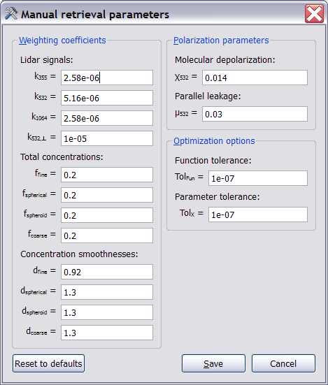

*Fig. 7. Algorithm parameters dialog b*o*x*

### Adjusting algorithm’s parameters

The function that is minimized by the algorithm includes lidar signal residuals (3 or 4 values, depending on the retrieval mode), and also residuals for total concentrations of the aerosol modes (2 or 3 terms) as well as 2 or 3 terms responsible for smoothness of the aerosol profiles being retrieved. Simultaneous optimization of these multiple heterogeneous parameters is accomplished by introduction of weighting coefficients whose values are to be chosen by the user on the basis of the algorithm’s convergence analysis.

You may adjust parameters of the retrieval process by means of the dialog box invoked via “Parameters” button located in the lower left corner of the main application window (see Fig. 1). Fields responsible for the weighting coefficients mentioned above are located in the left-hand part of the dialog box (see Fig. 7). Note that *f*coarse and *d*coarse coefficients won’t have any effect in the polarimetric retrieval mode, whereas *k*532,⊥, *f*sphecical,*f*spheroid, *d*shperical, and *d*spheroid won’t be used in the simplified retrieval mode.

In the right-hand part of the dialog box it’s possible to adjust some additional parameters of the algorithm:

* **“Molecular depolarization”** (χ532): depolarization ratio for the molecular atmosphere model (this value is assumed to be the same at any of the lidar wavelengths).
* **“Parallel leakage”** (μ532): portion of the parallel-polarized lidar signal that is estimated to penetrate the cross-polarized receiving channel, thus increasing the measured cross-polarized signal value.
* **“Function tolerance”** (TolFun): maximum value for decrease of the function being minimized between successive iterations that should trigger termination of the optimization process.
* **“Parameter tolerance”** (TolX): maximum value for change made to the parameters being optimized between successive iterations that should trigger termination of the optimization process (these optimization parameters are aerosol concentrations at various heights, as well as 3 or 4 lidar ratios at the reference points).

Pressing the “Save” button will apply new parameter values for all the subsequent runs of the retrieval algorithm. Pressing “Reset to defaults” button will reset all the values displayed in the dialog to their default values as defined within the application’s program code. Pressing “Cancel” button will close the dialog box without saving any changes.

### Estimation of square deviation of the retrieved aerosol parameters

The square deviation of the retrieved aerosol mode concentration variance can be estimated by a special procedure providing by the LIRIC. The *Errors modeling* module of the LIRIC package generates a disturbed input data set by adding the random noise into original lidar signals and by disturbing their linear characteristics, as well as by changing columnar optical characteristics of the aerosol layer. Real measurement conditions and technical features of the lidar system should be taken into account in setting parameters of the module.

You may adjust parameters of the errors modeling by means of the dialog box invoked via “Perturbance options” button located in the lower left corner of the main application window (see Fig. 1). The dialog box “LIRIC perturbance options” is shown in Fig. 8.

The left-hand part of the dialog box contains parameters responsible for:

* **“Enable perturbance analysis”** - switching-on of the perturbance analysis;
* **“Number of evaluations**” –number of realizations modeled;
* **“Linear factors**” – coefficient of linear distortions of lidar channels;
* **“Common linear factor”**  - common coefficient of the linear factors.

The central part of the dialog box contains parameters responsible for:

* **Phase function perturbance -** parameters responsible for perturbations of phase functions of aerosol modes (for coarse spheroid mode – perturbation of phase matrixes)
* **“Common factor”**  - common coefficient of the phase function pertubations .

The right-hand part of the dialog box contains parameters responsible for:

* **“Concentration perturbance” -** parameters responsible for perturbations of columnar aerosol mode concentrations of aerosol modes;

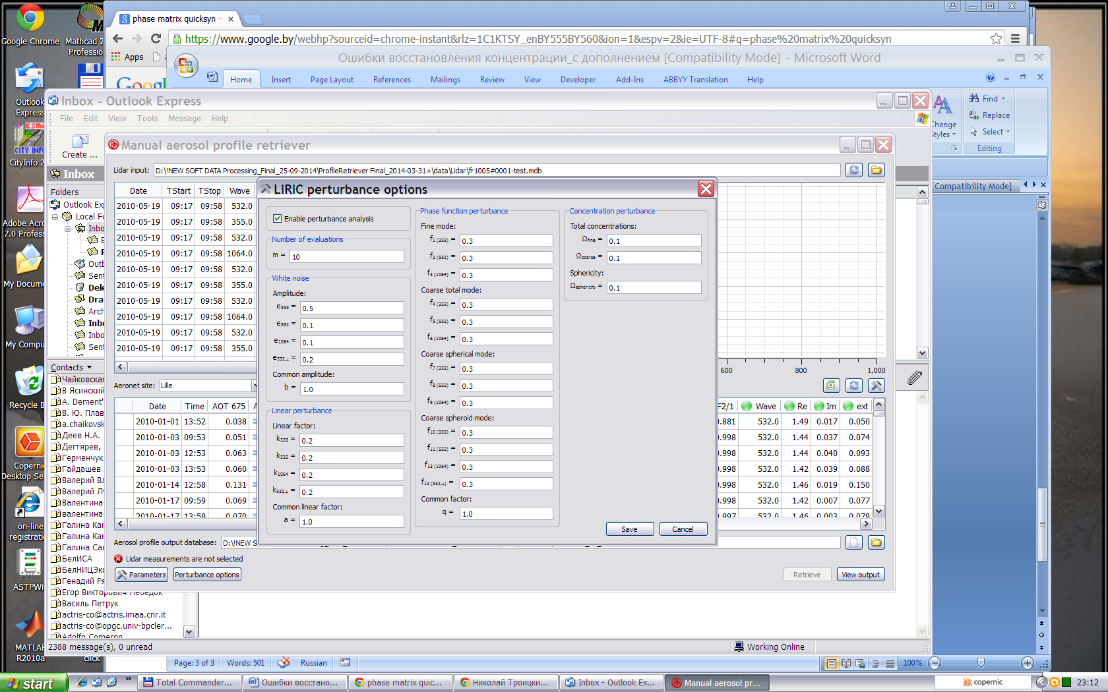

*Fig. 8. Pertuabence options parameters dialog b*o*x*

### Browsing of retrieved aerosol profile databases

For browsing of retrieved aerosol concentration profile databases, a separate **“OutputViewer”** application is provided, that may be launched either on its own or via the “View output” button located in the lower right corner of the main application window (see Fig. 1).

Graphical user interface of the “OutputViewer” application is represented on Fig. 9. To select a database file to be displayed in the application window, one has to press the “‍‍” (“Open”) button located in the top right corner of the window. It’s also possible to reload the currently opened database file by pressing the neighboring “‍‍” (“Reload”) button.

Contents of the loaded database are represented in the form of a table with the following columns (tooltips at table’s headers are also available for quick reference):

* **“Date”, “TStart”:** date and time of the beginning of the earliest of the lidar measurements used in the retrieval.
* **“TStop”:** completion time of the latest of the lidar measurements used in the retrieval.
* **“TPhoto”:** time of the radiometric measurement.
* **“DRetr”, “TRetr”:** completion date and time of the aerosol profile retrieval algorithm run.
* **“HStep”:** height step of the lidar data discretization grid, in meters (a common value for all the lidar signals).
* **“V-F”, “V-C”, “V-Cs”, “V-Cns”:** retrieved total volumetric concentrations of various aerosol modes (“Fine”, “Coarse”, “Coarse Spherical”, and “Coarse Spheroid”), in micrometers (in the simplified retrieval mode, “V-Cs” and “V-Cns” concentrations are actually calculated from “V-C”, using sphericity fraction provided by the AERONET inversion). These values are calculated on the basis of the retrieved aerosol concentration profiles and may be slightly different from the concentrations retrieved by the AERONET inversion algorithm.
* **“%sph”:** retrieved fraction of spherical aerosol particles, in percents (in the polarimetric retrieval mode, this will be the ratio between “V-Cs” and the sum of “V-Cs” and “V-Cns”; in the simplified retrieval mode, this value will be equal to sphericity fraction provided by the AERONET inversion).
* **“R-355”, “R-532”, “R-1064”, “R-532,⊥”:** residuals for the lidar signal components of the function that was minimized by the retrieval algorithm.
* **“R-F”, “R-C”, “R-Cs”, “R-Cns”:** residuals for total aerosol concentrations that had realized during the retrieval.
* **“Rsm-F”, “Rsm-C”, “Rsm-Cs”, “Rsm-Cns”:** residuals for smoothness terms of the function that was minimized.

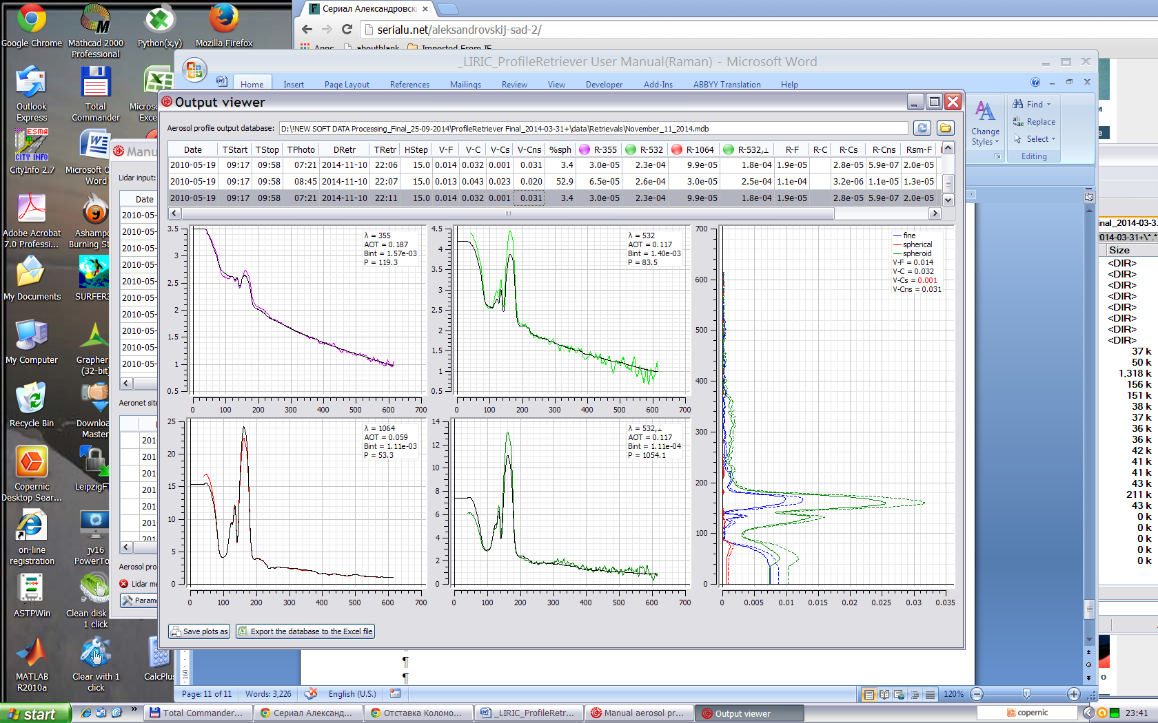

*Fig.9. Graphical user interface of “OutputViewer” application; dashed lines present aerosol parameters + square deviation.*

Lower part of the “OutputViewer” application window is occupied by plots that visually characterize results of the currently selected retrieval. These plots represent the same data that are displayed upon successful completions of aerosol profile retrievals, as described in Section 4 (see Fig. 6).

**“Save plots as”** button, located in the lower left corner of the application window, makes it possible to save the currently displayed plots in an image file, either in PNG (Portable network graphics) or EMF (Windows enhanced metafile) format.

**“Export the database file to an Excel file”** button makes it possible to export the entire database being displayed to a file in Microsoft Excel format, whose name and structure will be the same as those used in Excel file saving procedure described in Section 4.

It is possible to adjust sizes of window sections occupied by the table and the plots by dragging their horizontal boundary with mouse.

### Appendix. List of data fields of the aerosol profile output databases

The most important data fields of the aerosol profile output databases created by “ProfileRetriever” package may be accessed by means of the “OutputViewer” application, as described in Section 6. However, the actual number of stored parameters is considerably larger than that accessible via the user interface. In this appendix, the complete list of the output database data fields is provided, along with their data types:

* **“Latitude”, “Longitude”, “Altitude”** *(float32)***:** geodetic coordinates, in decimal degrees, and altitude above sea level, in meters, of the lidar measurement site (taken from the input lidar database). These values have to be the same for all the input lidar signals.
* **“StartDate”, “StopDate”, “StartTime”, “StopTime”** *(date/time)***:** date and time boundaries for the set of lidar measurements used in the retrieval (starting time of the earliest of the lidar measurements, and completion time of the latest one).
* **“PhotometerDate”, “PhotometerTime”** *(date/time)***:** date and time of the photometer measurement used in the retrieval.
* **“RetrievalDate”, “RetrievalTime”** *(date/time)***:** completion date and time of the aerosol profile retrieval algorithm run.
* **“Step”** *(float32)***:** height step of the lidar data discretization grid, in meters. This value has to be the same for all the lidar signals.
* **“Zenith”** *(float32)***:** zenith angle of the lidar data discretization grid, in degrees (this value is always zero).
* **“JoinIndex”** *(int16)***:** reserved for future use.
* **“Left_355”, “Left_532”,** **“Left_1064”, “Left_532C”,** *(float32) -* the left boundary of sounding and Raman signals.
* **“FineProfile”, “CoarseSphericalProfile”, “CoarseSpheroidProfile”, “CoarseProfile”** *(arrays of float32 values)***:** retrieved concentration profiles for the various aerosol modes, in ppb (if the retrieval had been carried out in the simplified retrieval mode, “CoarseSphericalProfile” as well as “CoarseSpheroidProfile” will contain no data; on the other hand, “CoarseProfile” will contain no data for polarimetric retrievals). These arrays are the main data retrieved by the algorithm.
* **“Measured_355”, “Measured_532”, “Measured_1064”, “Measured_532C”** *(arrays of float32 values)***:** measured lidar signals (normalized to their respective values at the reference points and with their molecular extinction components removed), corrected according to the retrieved lidar ratios (the last array is available for polarimetric retrievals only). These signal profiles are represented by color plots in “OutputViewer”.
* **“Calculated_355”, “Calculated_532”, “Calculated_1064”, “Calculated_532C”** *(arrays of float32 values)***:** lidar signals calculated in accordance with the retrieved aerosol concentration profiles (the last array is available for polarimetric retrievals only). These signal profiles are represented by black plots in “OutputViewer”.
* **“IDLocal_355”, “IDLocal_532”, “IDLocal_1064”, “IDLocal_532C”** *(text fields, up to 255 characters)***:** textual identifiers that were assigned to input lidar measurements during the lidar experiments (the last value is available for polarimetric retrievals only).
* **“IDLocalNear_355”, “IDLocalNear_532”, “IDLocalNear_1064”, “IDLocalNear_532C”** *(text fields, up to 255 characters)***:** reserved for future use.
* **“PhotometerVFine”, “PhotometerVCoarse”, “Sphericity”** *(float32)***:** volumetric concentrations of “Fine” and “Coarse” aerosol modes, in micrometers, and fraction of spherical aerosol particles, in percents, as retrieved by the AERONET inversion algorithm. Note that these values may be slightly different from those specified in “V-F”, “V-C”, and “%sph” columns in “OutputViewer”, which are based on the retrieved aerosol profiles rather than original AERONET data.
* **“AtmoModel”** *(text field, up to 255 characters)***:** textual identifier for the molecular atmosphere model that was specified in the “TropoExport” tool during preparation of the lidar data: either “STD” for International Standard Atmosphere 1976, “CIRA” for COSPAR International Reference Atmosphere 1986 or “CUST” for a custom molecular atmosphere model.
* **“Polarization_355”, “Polarization_532”, “Polarization_1064”** *(int16)***:** types of the measured ordinary (not cross-polarized) input lidar signals: these values may be either “0” (for unpolarized input signals) or “3” (for parallel-polarized ones).
* **“StdDeviation_355”, “StdDeviation_532”, “StdDeviation_1064”, “StdDeviation_532C”** *(arrays of float32 values)***:** estimated dispersions for the input lidar signals that were used during the retrieval (the last array is available for polarimetric retrievals only). These values are calculated by the “TropoExport” tool during the lidar signal preparation procedure.
* **“B<*mode>*_<*wavelength>*”, “B<*mode>*_<*wavelength>*P”, “B<*mode>*_<*wavelength>*C”** *(float32)*, where *<mode>* is one of “Fine”, “Spherical”, “Spheroid”, and “Coarse”, whereas *<wavelength>* is one of “355”, “532”, and “1064”**:** aerosol backscatter coefficients provided by the AERONET inversion algorithm. “P” and “C” suffixes are used to denote parallel and cross-polarized backscatters, whereas fields without such a suffix represent unpolarized backscatters. Depending on polarization setup of the lidar inputs, either unpolarized or parallel-polarized versions of the coefficients are used during the retrieval for ordinary (not cross-polarized) lidar signals. Cross-polarized backscatters are used in polarimetric retrieval mode only, for the cross-polarized lidar channel at 532 nm.
* **“A<*mode>*_<*wavelength>*”** *(float32)*, where *<mode>* and *<wavelength>* take the same values as in the above case**:** aerosol attenuation coefficients provided by the AERONET inversion algorithm.
* **“Weight_355”, “Weight_532”, “Weight_1064”, “Weight_352C”** *(float32)***:** weighting coefficients for the lidar equations (see Section 5).
* **“Weight_Fine”, “Weight_Spherical”, “Weight_Spheroid”, “Weight_Coarse”** *(float32)***:** weighting coefficients for the aerosol concentration equations (see Section 5).
* **“WeightSmooth_Fine”, “WeightSmooth_Spherical”, “WeightSmooth_Spheroid”, “WeightSmooth_Coarse”** *(float32)***:** weighting coefficients for the aerosol profile smoothness equations (see Section 5).
* **“MolDepolar_532”, “Leakage_532”** *(float32)***:** molecular depolarization ratio at 532 nm, and portion of the parallel-polarized lidar signal that is estimated to penetrate the cross-polarized receiving channel at 532 nm (see Section 5).
* **“RE OMT_355”, “RE OMT_532”, “RE OMT_1064”, “RE OMT_532C”** *(float32)***:** estimates for relative errors of molecular optical thicknesses at input lidar channels (as specified in the “TropoExport” tool).
* **“RE OAT_355”, “RE OAT_532”, “RE OAT_1064”, “RE OAT_532C”** *(float32)***:** estimates for relative errors of aerosol optical thicknesses at input lidar channels (as specified in the “TropoExport” tool).
* **“RE GBS_355”, “RE GBS_532”, “RE GBS_1064”, “RE GBS_532C”** *(float32)***:** relative errors of lidar ratio estimations (as specified in the “TropoExport” tool).
* **“Ratio_355”, “Ratio_532”, “Ratio_1064”, “Ratio_352C”** *(float32)***:** retrieved lidar ratios for the various lidar channels (the last value is available for polarimetric retrievals only).
* **“Residual_355”, “Residual_532”, “Residual_1064”, “Residual_352C”** *(float32)***:** residuals for the lidar signal components of the function that was minimized by the retrieval algorithm.
* **“Residual_Fine”, “Residual_Spherical”, “Residual_Spheroid”, “Residual_Coarse”** *(float32)***:** residuals for total aerosol concentrations that had realized during the retrieval.
* **“ResSmooth_Fine”, “ResSmooth_Spherical”, “ResSmooth_Spheroid”, “ResSmooth_Coarse”** *(float32)***:** residuals for smoothness terms of the function that was minimized.
* **“PerturbanceEvaluations”, “WhiteNoise_355”, “WhiteNoise_532”, ……. “LinearNoise_535”, “LinearNoise_Raman”** *(float32)***:** parameters of *Pertuabence options parameters dialog b*o*x*

***“Arrays” page of the Excel table:***

* **“BackscatterMin1Profile”:** profile of “backscatter ratio-1”
* **“LidarRatioProfile”:** lidar ratio profile.
* **“Measured_Source”, “Measured_Raman”:** measured sounding and Raman signals.
* **“Calculated_Source”, “Calculated_Raman”:** calculated sounding and Raman signals.
* **“StdDeviation_Source”, “StdDeviation_Raman”:** deviations of sounding and Raman lidar signals (as specified in the “TropoExport” tool).
* **“MolBackscatter”:** Molecular backscatter coefficient profile (model) (as specified in the “TropoExport” tool).
* **“AerBackscatter”:** Aerosol backscatter coefficient profile (retrieved) .
* **“AerExtinction”:** Aerosol extinction coefficient profile (retrieved) .
* **“BackscatterMin1Dispersion”:** square deviation of the backscatter ratio-1” profile.
* **“LidarRatioDispersion”:** square deviation of the lidar ratio profile.