# ProfileRetriever Software Package:

# Implementation of Lidar-Radiometer Inversion Code (LIRIC)

# with Graphical User Interface

## Software Installation Guide

***Note:*** *in addition to components included in the installation package, this software will also require Microsoft Access to be installed on your computer in order to work properly. This software will run on Microsoft Windows XP and higher operating systems.*

1. **Install “Python(x,y)” distribution of the Python programming language:**

You may either use the “Python(x,y)-2.6.6.0.exe” file included in this installation or download the most recent version of the “Python(x,y)” distribution yourself from <http://www.pythonxy.com>. (Or, alternatively, you may use any other distribution of the Python programming language (version 2.6 or 2.7), provided that you also download and install any of the required libraries listed below).

During the setup process, please pay attention to “Choose Components” pane (Fig. 1):

* Select “Full” in the “Select the type of install” combobox or make sure that at least the following libraries are selected under the “Python” group of the component tree: “PyQt”, “PyQwt”, “SetupTools”, “h5py”, “Pywin32”, “xlrd”, and “xlwt”.
* If you want the software to be used by several users, expand “Install for” and check “All Users”.
* If you want the Python language interpreter to be installed in a directory different from “C:\Python26”, expand “Directories” and check “Custom”. You will be prompted to select an appropriate directory later on. Note however that you may not place the Python interpreter on a directory path that contains spaces.
* Optionally clear “Eclipse” and “Other” checkboxes in the component tree if you are not going to use software development tools bundled with Python(x,y).

***Note:*** *You may need to restart your computer in order to complete this step of the installation process.*

1. **Install MATLAB Compiler Runtime:**

Run the **“MCRInstaller.exe”** file included in this installation and follow the instructions.

1. **Install aerosol profile retrieving software itself:**

Unpack the contents of **“ProfileRetriever 2012-08-02.zip”** file to any convenient location on your hard drive.

The software should be immediately ready for use. To run an application, switch to the application folder and double-click the required program file:

* to launch aerosol profile retrieval graphical user interface program, double-click **“ManualRetriever.pyw”**;
* to launch viewer of aerosol profile output database files, double-click **“OutputViewer.pyw”.**

You may also create shortcuts to these program files and place them on the Desktop or in Start menu.

You may change location of the application folder at any time in the future, if required.

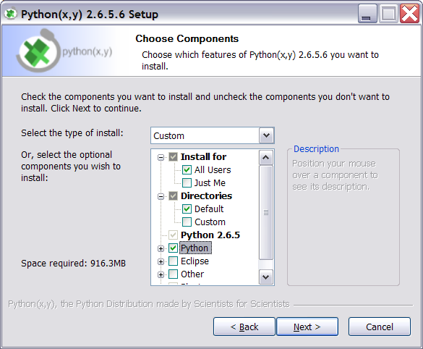

*Fig. 1. “Choose Components” pane of the Python(x,y) installation wizard.*